Module 2 Lesson 2:

Writing equations and

Modeling with

Polynomials

**Learning Targets**

SWUT:

You can use polynomials to model many real world situations.

The behaviors of the graphs of polynomial functions of different degrees can suggest which will best fit a particular real-world data set.

You can use the regression feature of a calculator to help find functions to model data sets.

The closer $r^{2}$ is to 1 the better the fit of the model.

For any set of $(n+1)$ points in the coordinate plane that pass the vertical line test, there is a unique polynomial of degree at most $n$ that fits the point perfectly.

**Using Rational and Complex Zeros (a + bi) to Write Polynomial Equations.**

***Example:*** A polynomial function has real coefficients, a leading coefficient of 1, and the zeros -1, -2, and 5. Write a polynomial function of least degree in standard form.

**Step 1: Convert the zeros to factors (*reverse booty cheek/t-bone process*)**

**Step 2: Place the leading coefficient in front.**

**Step 3: Multiply the factors**

**Step 4: Combine like terms and write with powers of x in descending order, which is the standard form of a polynomial function.**

***Example 2*:** What is a cubic polynomial function in standard form with zeros -2, -3, and 3 and a leading coefficient of -2?

***Example 3:*** If the leading coefficient is 1, what is a quadratic polynomial function with zeros $\frac{1}{2}$ and 4?

***Example 4:*** What is a cubic polynomial function with zeros 2, $i$ and $-i$?

*Note: Complex roots always come in conjugate pairs.

***Example 5:*** If you know two roots of a polynomial are 3i and -7i, list all the roots and state if it is a linear, quadratic, cubic or quartic polynomial?

***Example 6:*** Find the general equation of the cubic equation having roots 3, -2, and 1.

Now let’s find the specific equation of the cubic equation having roots 3, -2, and 1 and passing through the point (-1,-12)

**Writing Equations of Polynomial Functions in Real Life**

**Refresher**

|  |  |
| --- | --- |
| Month | Snowfall (inches) |
| 1 October | 0.1 |
| 2 November | 7.3 |
| 3 December | 21.8 |
| 4 January | 28.2 |
| 5 February | 21.5 |
| 6 March | 16.3 |
| 7 April | 3.9 |

Given the data on monthly snowfall in Rochester, make a scatter plot and find a *quadratic* model that best fits this data. *Round all coefficients to the nearest ten thousandth.*

http://www.currentresults.com/Weather/New-York/Places/rochester-snowfall-totals-snow-accumulation-averages.php

y=

Talk with your neighbor, is this a good model to use?

How can we tell?

Now find a Cubic model. (Stat - calc - 6)

Is this model better?

**Practice *(any rounding is to the thousandths place)***

1. Find a cubic function going through (0,-3), (1, -1), (2, 5) and (-1, -7).
2. Find the quadratic functions that passes through (-2, -16), (3, 11) and (0,2).

**CLASSWORK/HOMEWORK:**

**Practice with real life applications.**

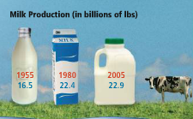The chart shows milk production that Wisconsin dairy farmers produced. Make a scatter plot. Is a linear or quadratic model better? Let x be the years since 1900. Justify your answer.

Note: since we only have three data points, we cannot choose a polynomial function with degree 3 or more. You need at least $n+1$ points to look at a model, where $n$ is the degree of the model.

Did you look at the end behavior? Does your model work?

**Air Travel** The table shows the percent of on-time flights for selected years. Find a polynomial function to model the data (hint: remember n+1 points mentioned in previous problem).

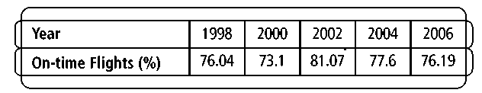

**Example**

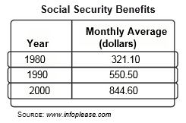Find a polynomial function that best fits the data. Let $x$ = the number of years after 1980. Justify your answer. *Round coefficients to the nearest thousandth.*

Using your model, what would be your prediction for social security benefits in the year 1992? Is this a good model for this prediction?

Using your model, what would be your prediction for social security benefits in the year 2015? Is this a good model for this prediction?